# Exp: 1

**Draw a UML diagram for hotel reservation system. In a hotel reservation system, a customer can make online booking for a hotel, by specifying the accommodation requirements such as type of room (AC/Non-AC, One bed/two bed), total no of rooms, duration of stay. The system selects a suitable hotel as per customer’s requirements. If a hotel is found then the availability of rooms in that hotel is checked. The charges are calculated for the selected requirement and these are acknowledged to the customer. If the customer is satisfactory about the selection made by the system, then he confirms the reservation.**

**Aim:**

To design a UML Use Case Diagram for a Hotel Reservation System that automates the process of booking a hotel room based on customer preferences, availability, and pricing.

**Procedure:**

1. Open Umbrello & Create Diagram then Select the appropriate UML diagram type.
2. Add Elements and Insert actors, classes, objects, states, or activities as required.
3. Define Relationships with Connect elements using associations, dependencies, or transitions.
4. Label & Arrange Components of Name all elements properly and structure them clearly.
5. Save & Export to Finalize the diagram and export it as an image or PDF for documentation.

**Sequence Diagram:** 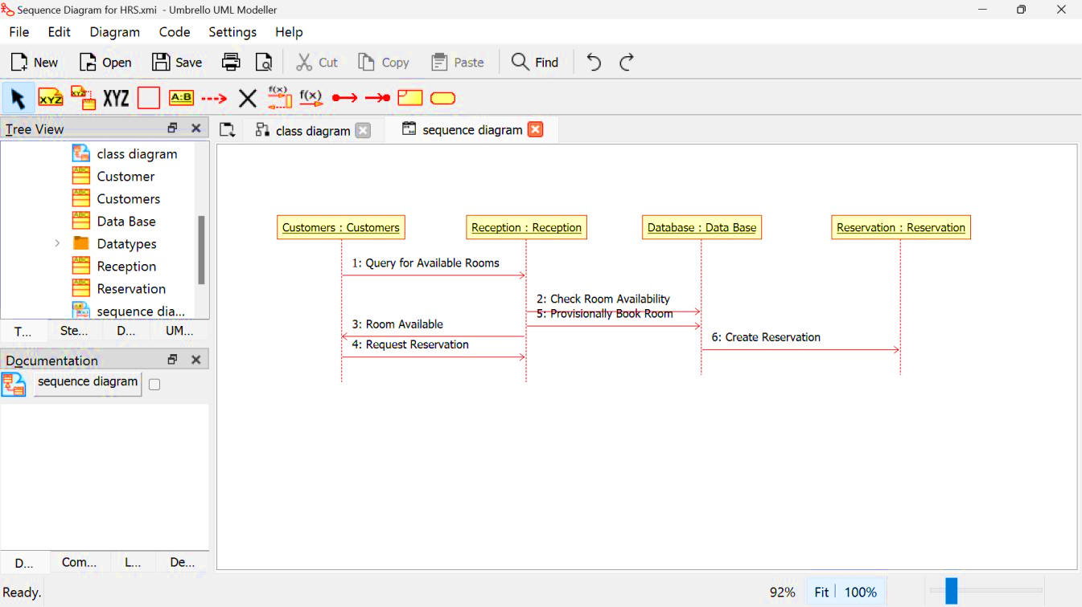

# Class Diagram

# State Diagram

# 

# Use Case Diagram

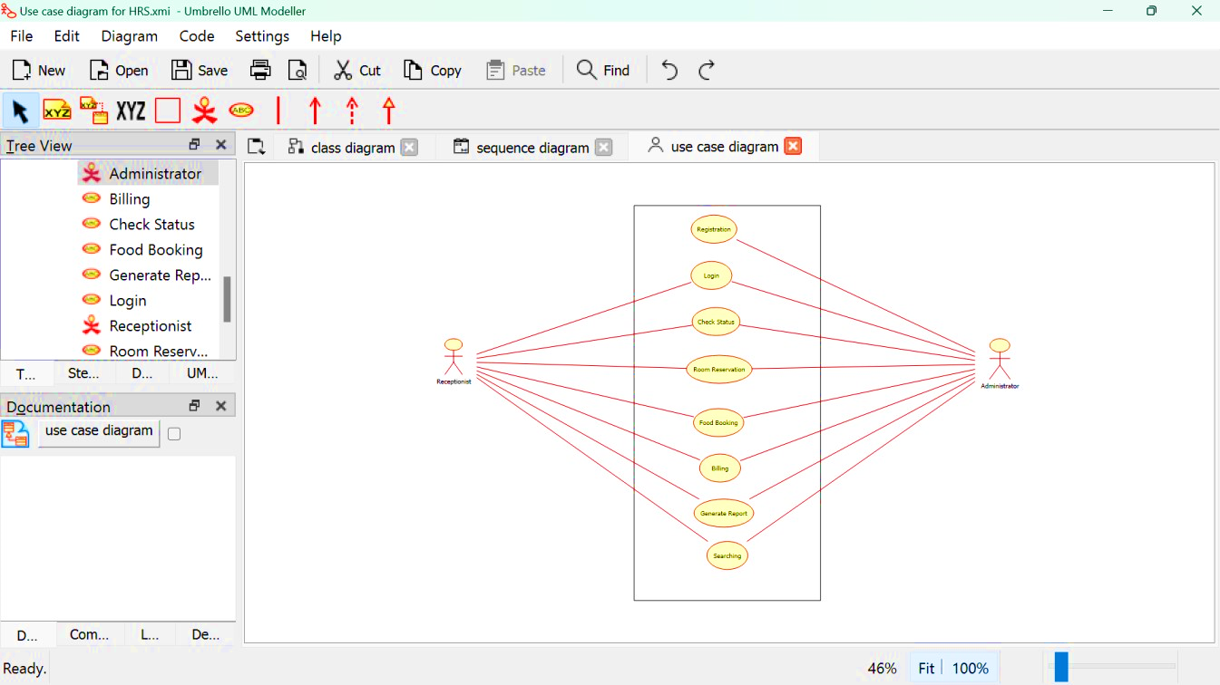

**Component Diagram:**

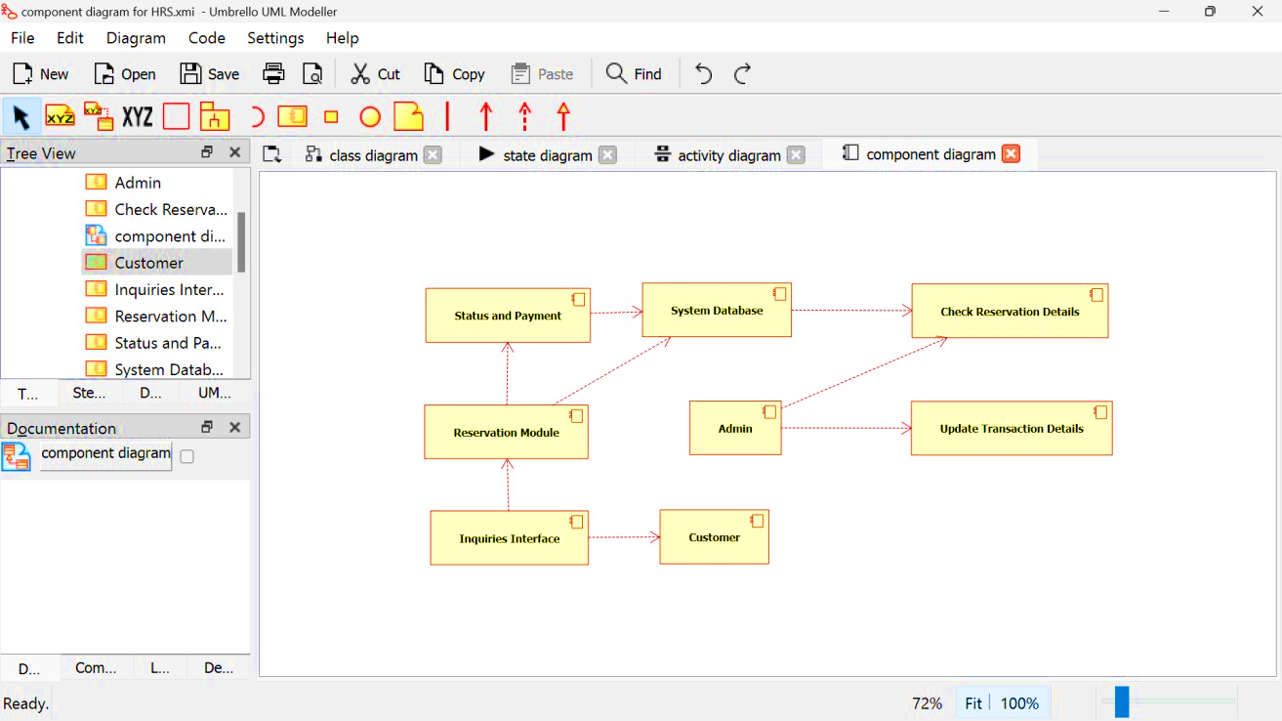

# Activity Diagram

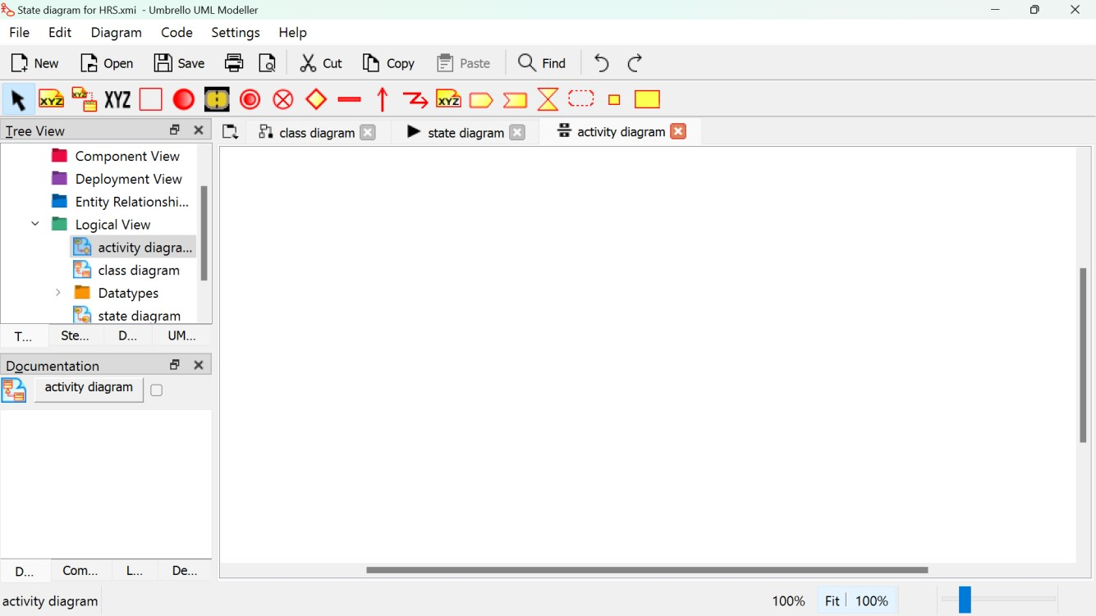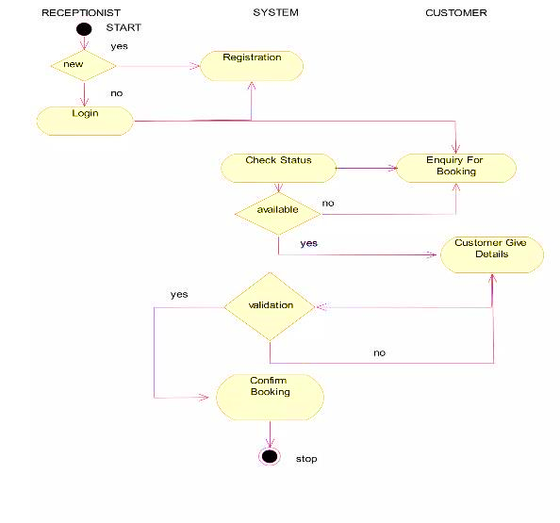

**Deployment Diagram:**

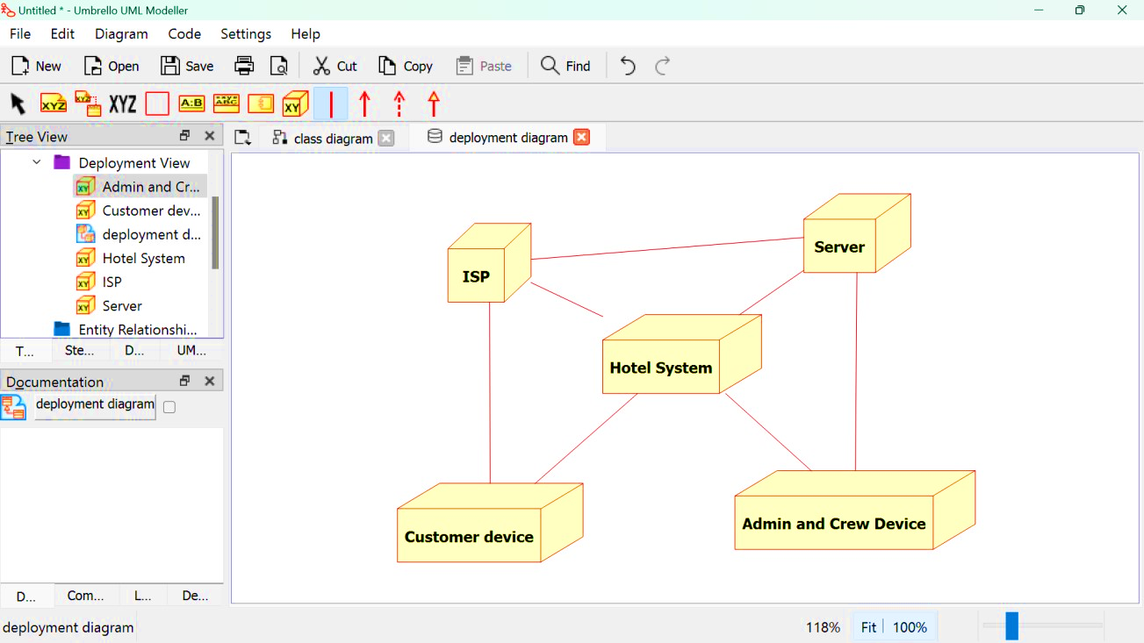

# Communication Diagram

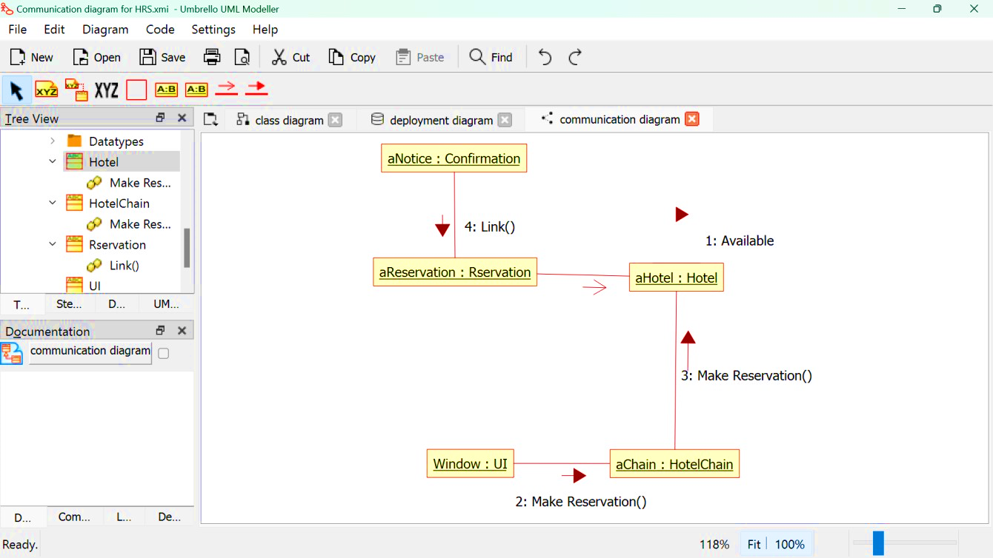

# Object Diagram

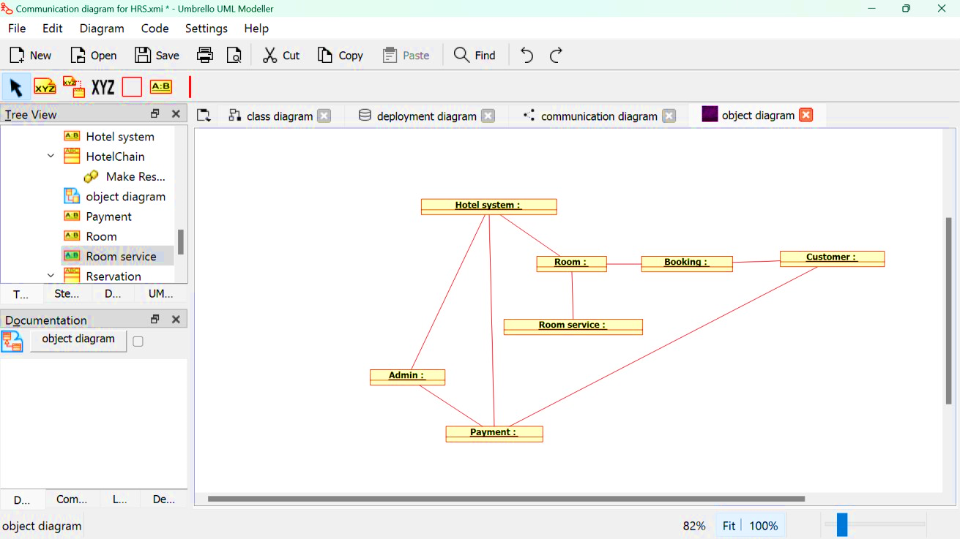

**Result:**

Thus, the UML diagrams are successfully created using Umbrello Software.